Tasks

Introduction
In this Task you will have the opportunity to get familiar with and manipulate the main components of a Data Warehouse (Data Mart). The DW is implemented in Access, an easy-to- use tool for creating business applications. The case study used here is a grocery store application (sales data). By consulting the related tables created for this example, you will learn about the typical modelling of a DW (star schema) and the different way to explore its dimensions.
The objective of this tutorial is to understand the flexibility of the Cube modelling to summarize and consult a large quantity of data according to different business perspectives. To do so, you will have to select and display the relevant content of the DW in an Excel pivot table. You will realise that the pivot table is a very useful data processing tool to extract information from a large and detailed dataset in a quick and easy way.

Task
  - Tutorial
Complete the video tutorial available here: https://www.youtube.com/watch?v=eGhjklYyv6Y
The video is presenting a grocery DW (actually, it is a Data Mart), which is modelled through a

Star schema.
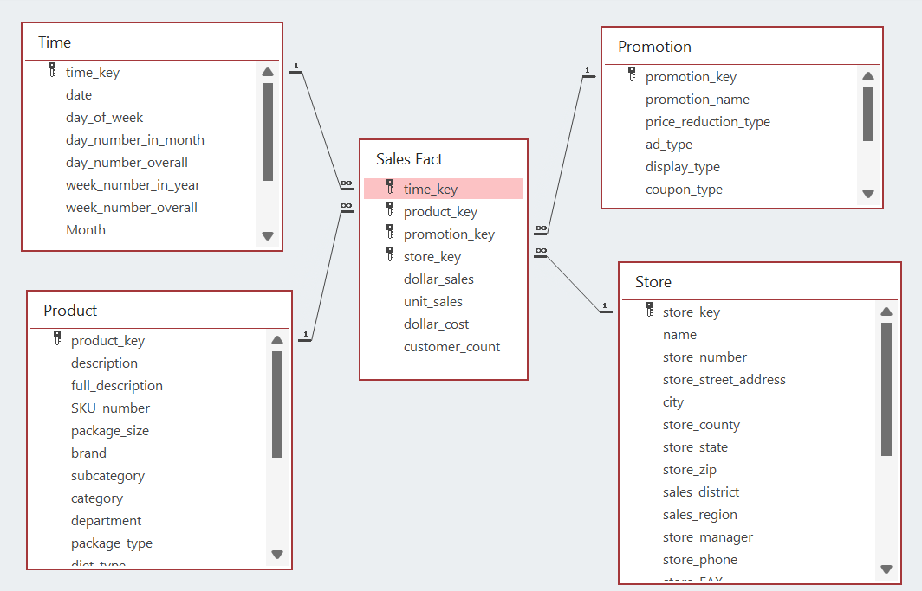
Description of the figure above:
- 1 Fact Table: ‘Sales Fact’ which stores measures (dollar_sales, unit_sales, dollar_cost, customer_count).
- 4 Dimensions: When (Time table), What (Product table), Where (Store table), and Why (Promotion).

- Link between the tables: The primary key for all the four dimensional tables has been placed as foreign key in the fact table.
- Explore the several tables and try to understand their content and how they are related to each other.
- Connect an Excel file to the DW and create Pivot table as demonstrated on the video.
- Understand how the several dimensions can be used and manipulated to analyse the business performance of the company according to different views (roll-up, drill-down, slice and pivot).

  - Exercises
Use the DW and the Pivot table to answer the questions as follows:
    - How many products did the store No. 19 sale in 1994?
Ans:- Store No. 19 sold 14,016 products (units) in the year 1994.
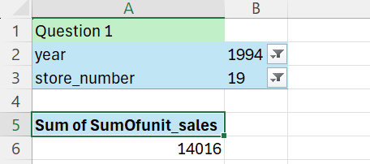
    - Which type of promotion provides the highest amount of unit sales?
Ans:- Among the promotional campaigns, POS Grabbers provides the highest amount of unit sales, with a total of 41,949 units sold,
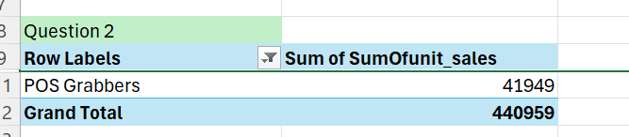
    - Which are the top 10% best stores in terms of dollar sales in 1995?
Ans:- The top 10% best-performing stores in terms of dollar sales are Store No. 8 and Store No. 12, with total dollar sales of 21,563.91 and 22,647.59 respectively for the year 1995
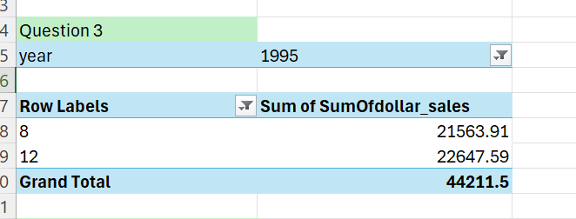

    - Which one of the stores has the highest amount of customers?
ANS:- The analysis shows that Store No. 8 and Store No. 10 have the highest and equal number of customers, with a total customer count of 21,843 each.
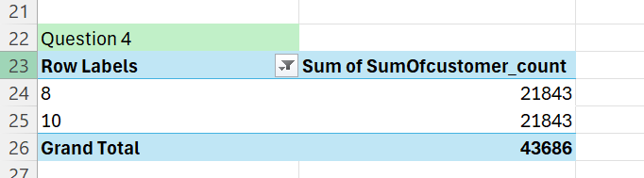
    - Which product is the most lucrative?
ANS:-Based on the profit analysis using the Pivot Table, Buffalo Jerky is the most lucrative product, generating a total profit of 11,022.52.
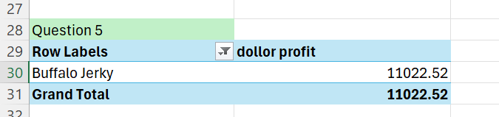
    - What was the most lucrative day, month, and year?
ANS:- Using the profit-based analysis derived from the Pivot Table, it was observed that the most lucrative year was 1994, generating a total profit of 54,282.79. The most lucrative month was November, with a profit of 37,367.45, and the most lucrative day was the 21st, yielding a profit of 3,838.97.
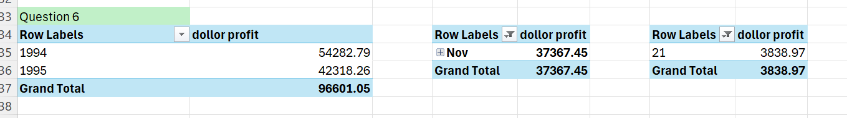

Draw conclusions about the pros and cons regarding the use of a DW to support decision making.

Pros of Using a Data Warehouse for Decision Making
- Integrates data from multiple sources into a single, consistent repository
- Provides historical data, enabling trend and pattern analysis
- Supports fast and complex analytical queries
- Enables multidimensional analysis (roll-up, drill-down, slice, pivot)
- Improves data accuracy and consistency for reporting
- Does not affect operational (OLTP) system performance
- Helps management make data-driven and strategic decisions

Cons of Using a Data Warehouse for Decision Making
- High initial setup cost (hardware, software, and development)
- Requires time-consuming ETL processes
- Data may not be real-time due to batch updates
- Needs skilled technical resources for maintenance
- High storage requirements for large historical datasets
- Changes in business requirements may require redesign

